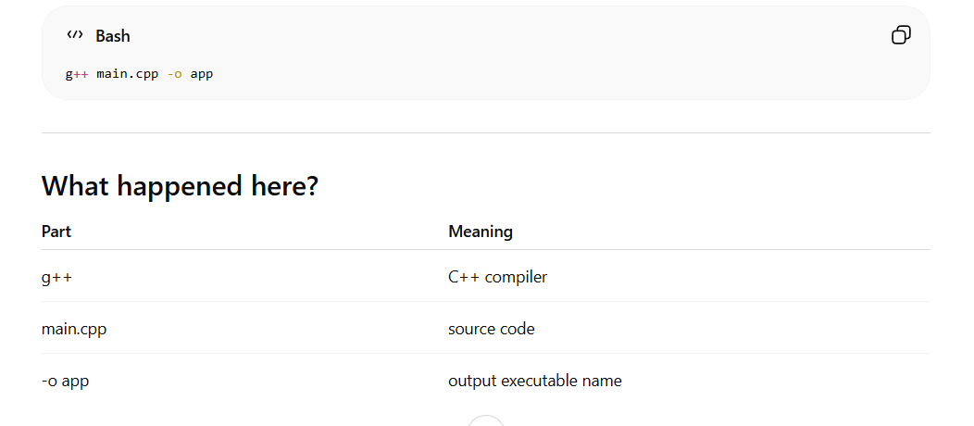
Name – user , Password - user

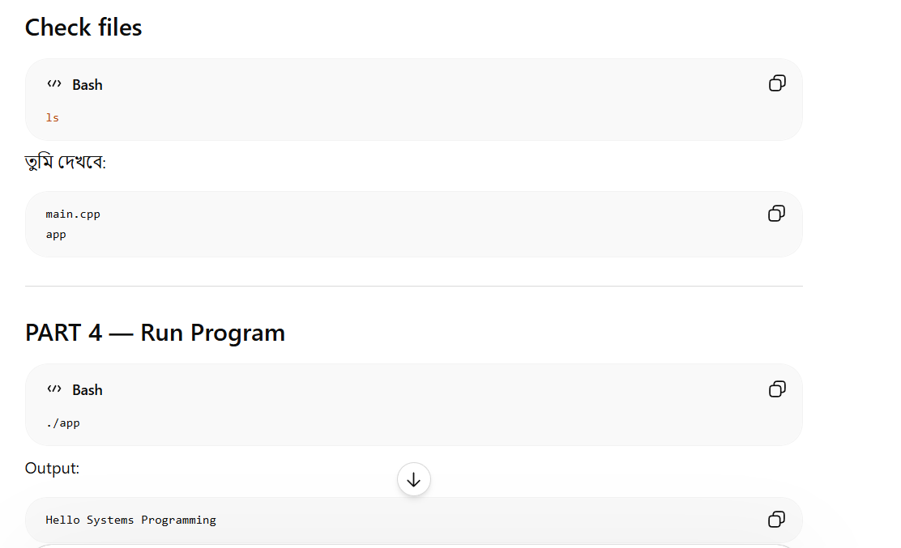
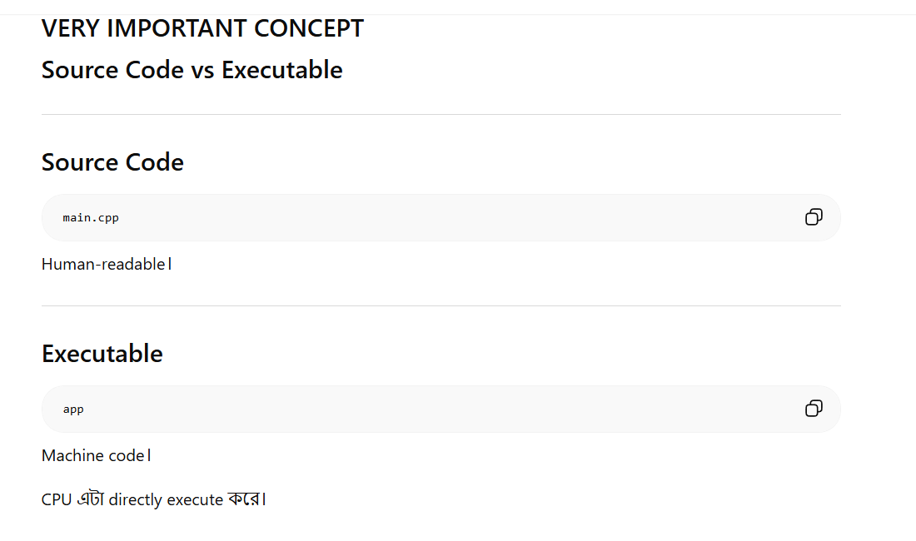

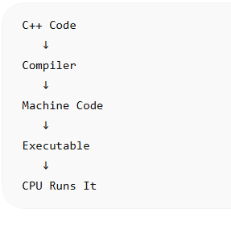

Create file - touch test.txt
Delete file - rm test.txt
Copy file - cp main.cpp backup.cpp
Rename file – mv backup.cpp old.cpp

Executable type -
ELF 64-bit executable
ELF is Linux executable format।

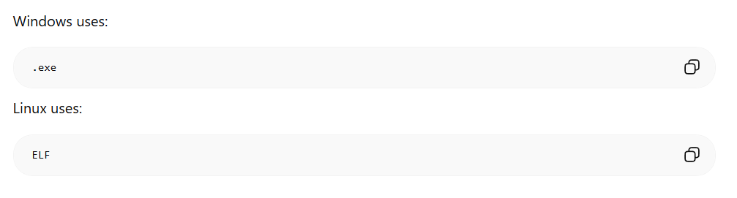

Warning flags –
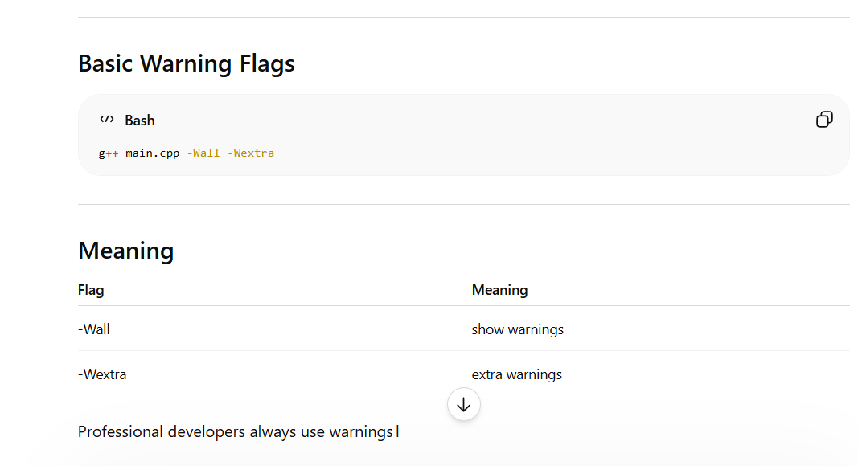

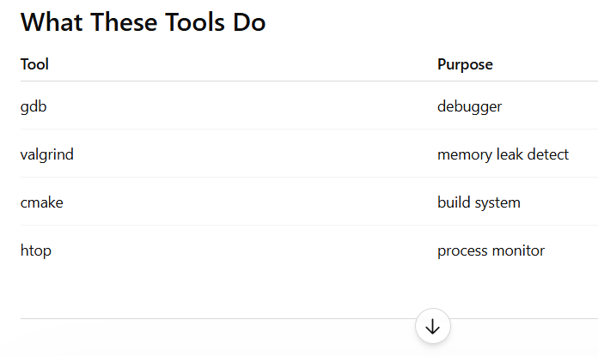
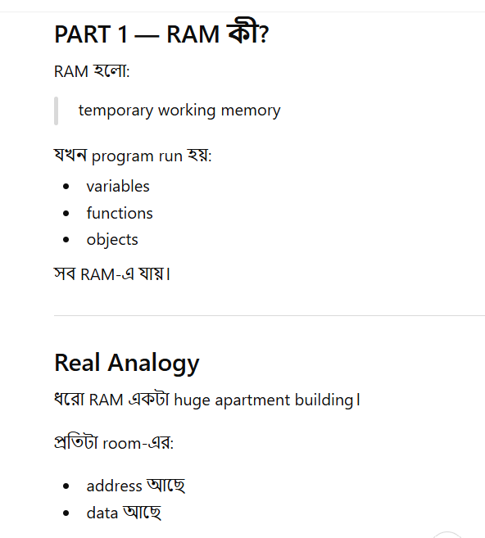

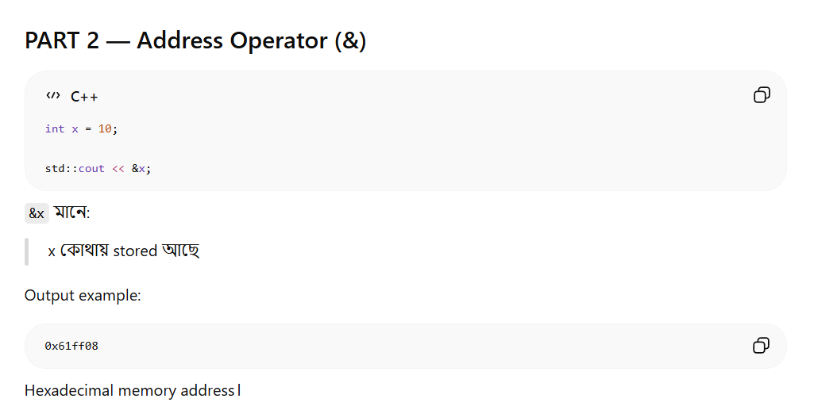

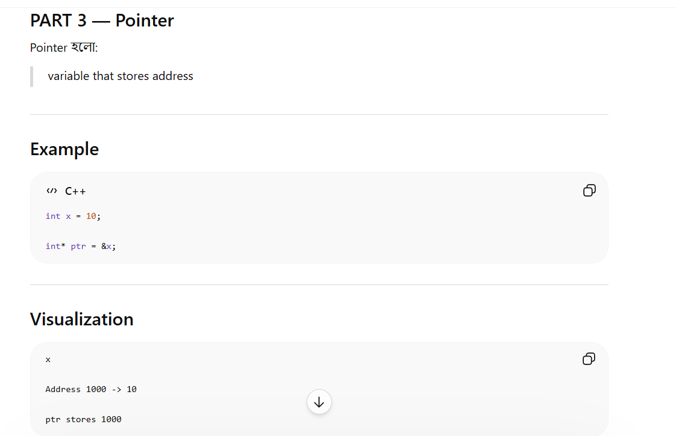

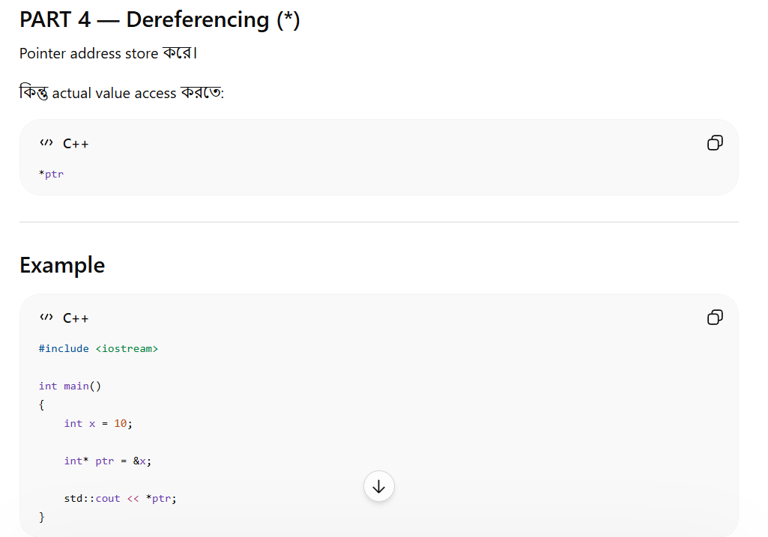

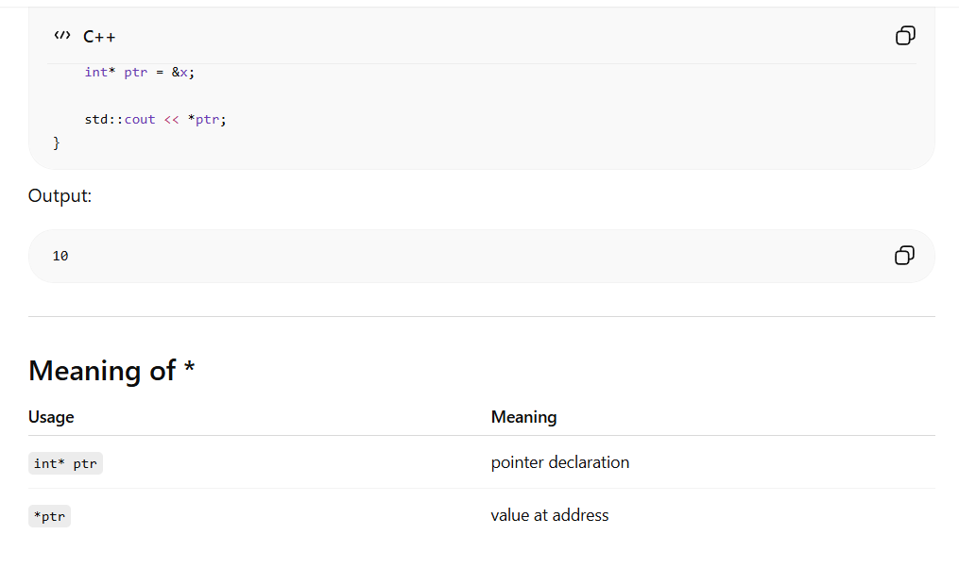

x = 10

&x -> address of x

ptr = address

*ptr = value at that address

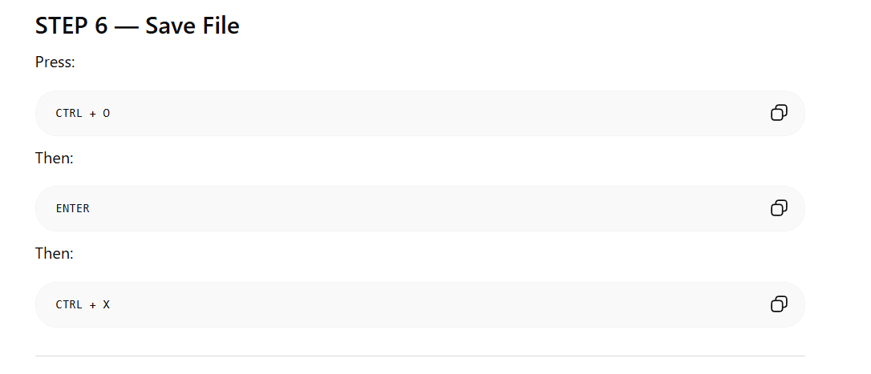
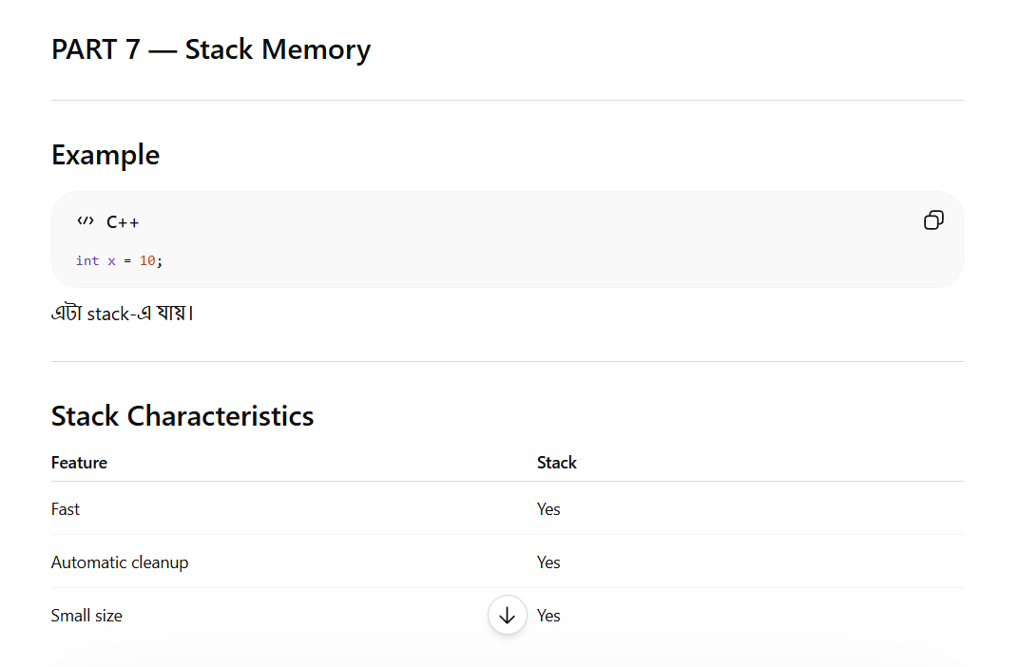
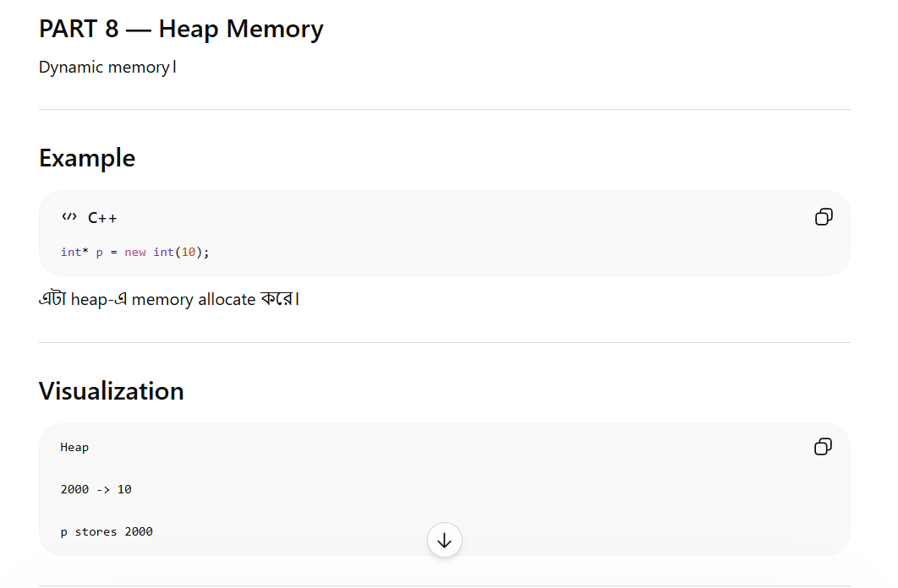
VERY IMPORTANT
Stack auto cleanup করে।
Heap manual cleanup লাগে।
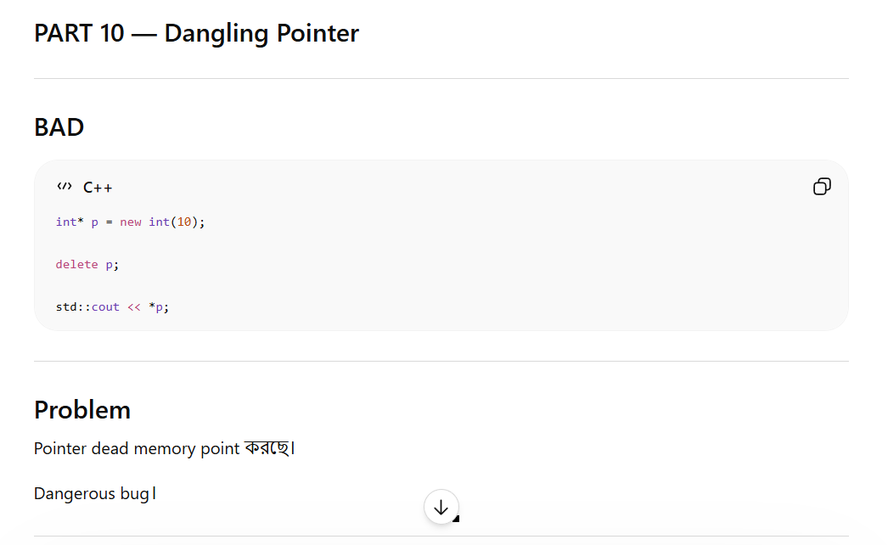
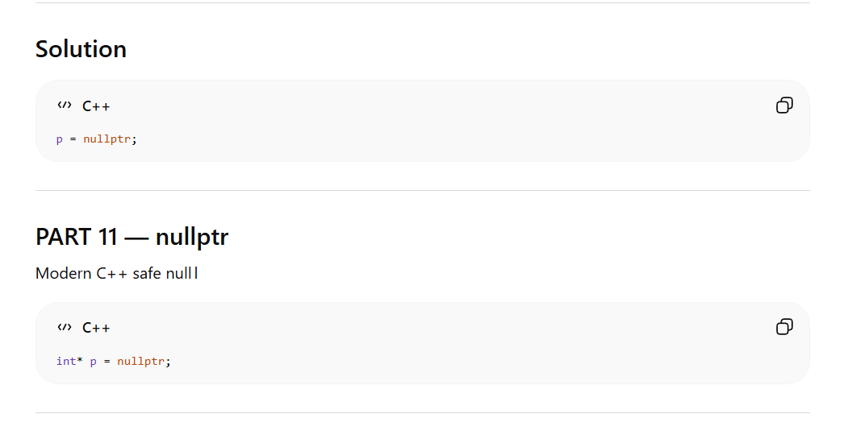
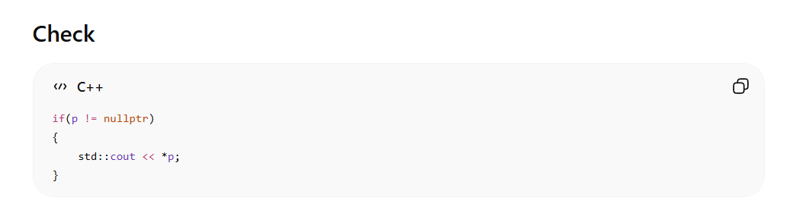

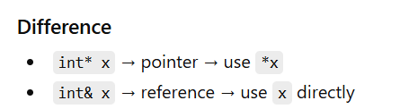
Function call = stack frame creation

Classes & objects -
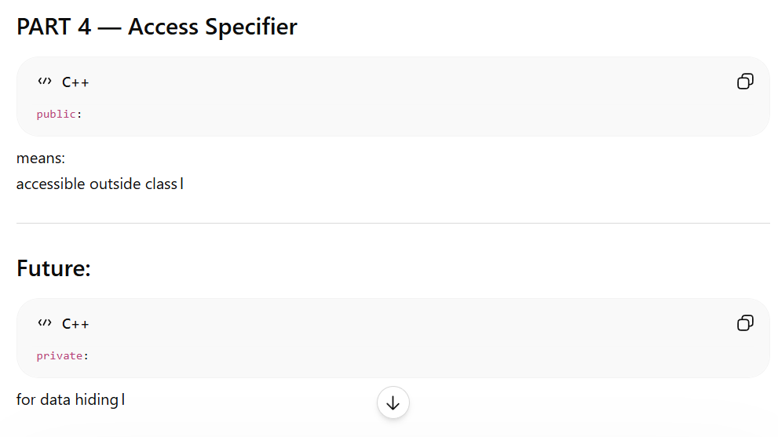

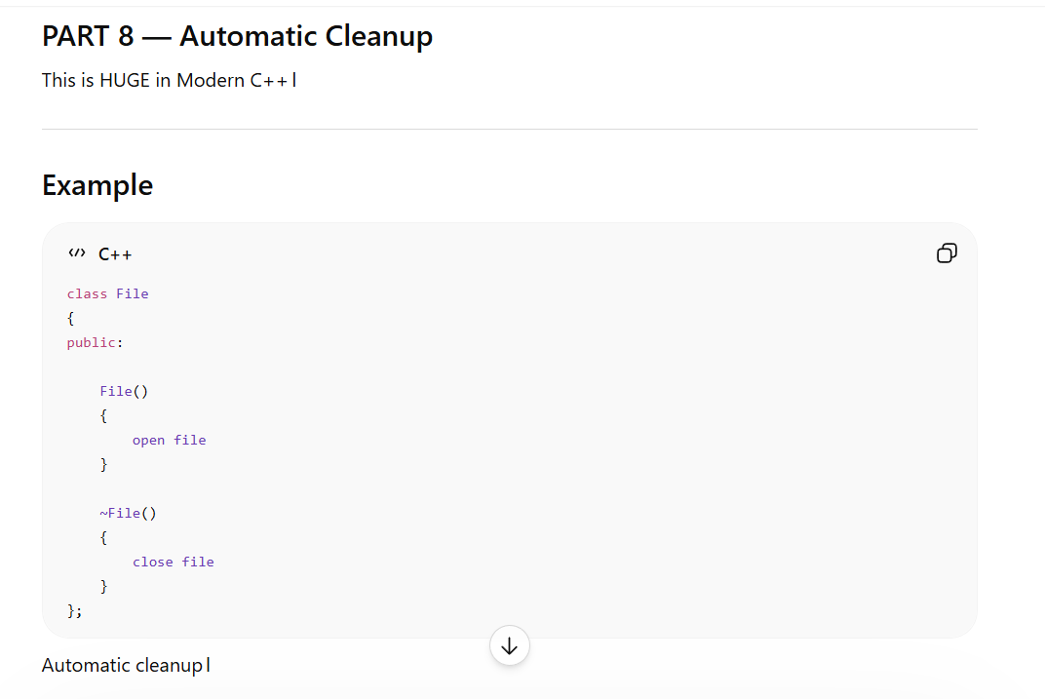

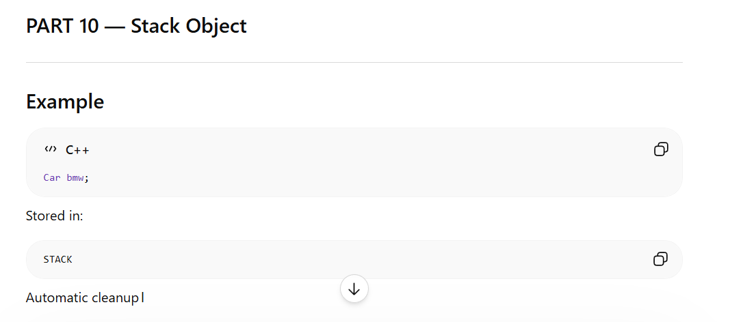

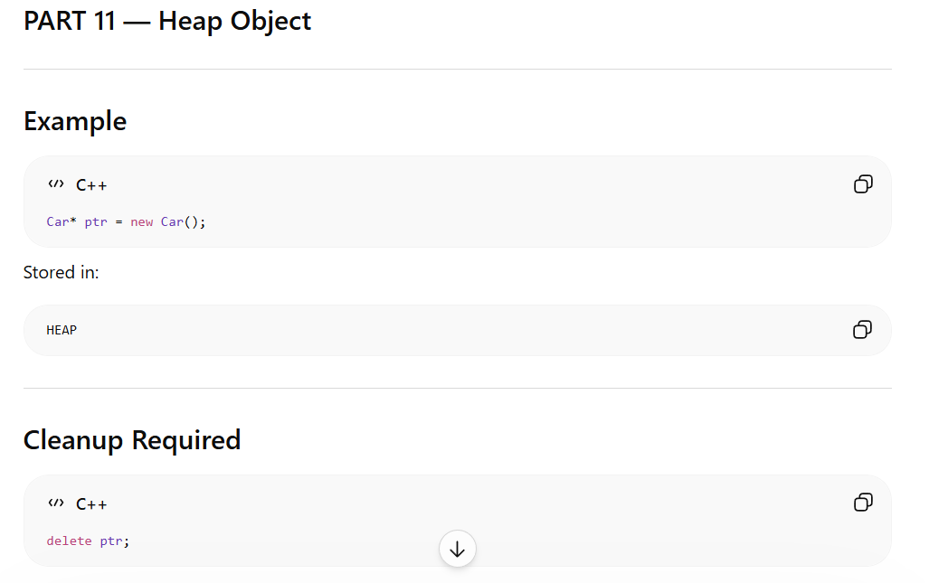
ptr -> start(); way to call the function by pointer

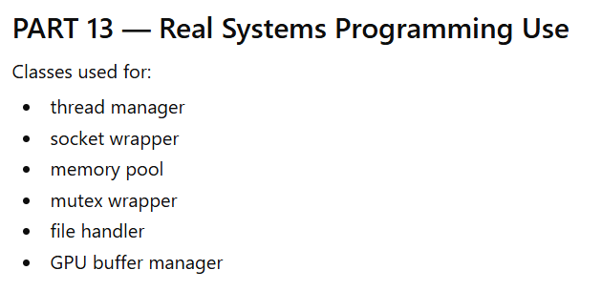

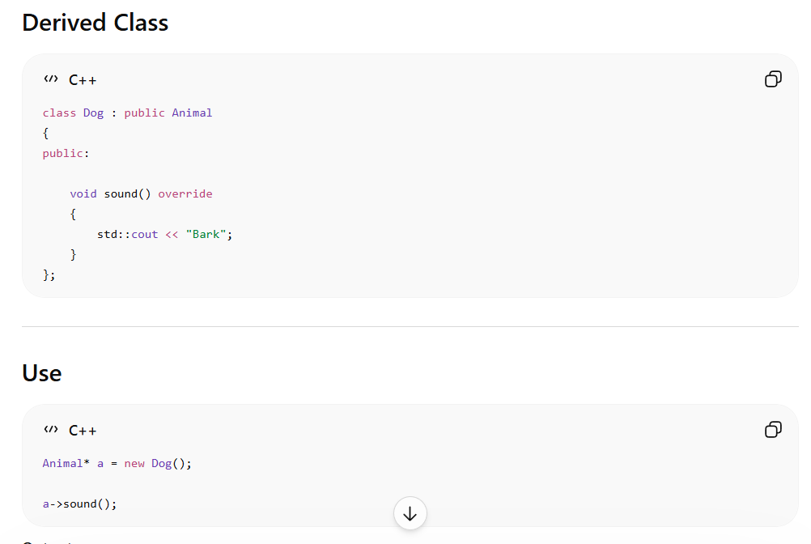
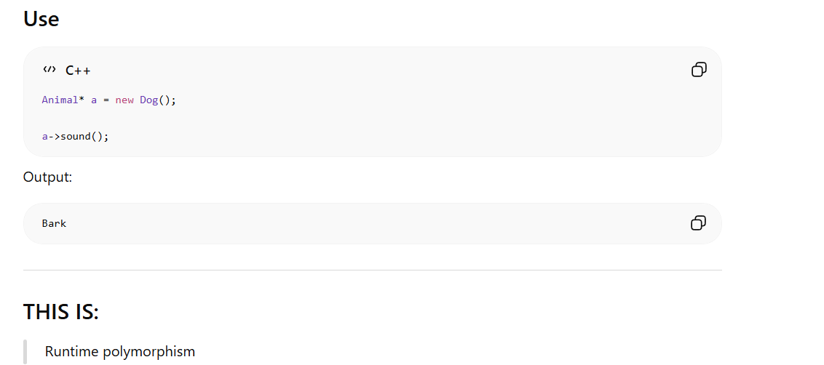

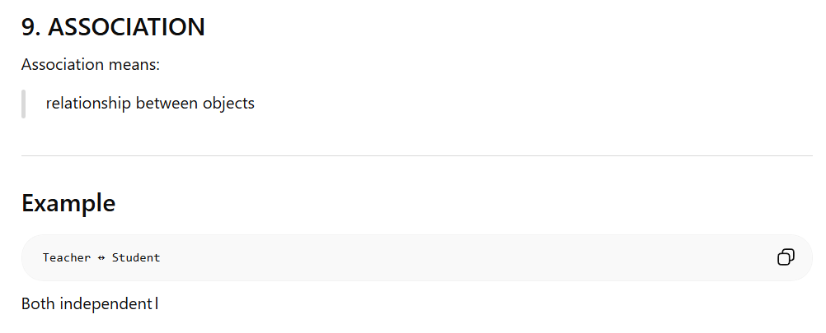
Association
“Uses Relationship”
Association means:
two objects connected
BUT both can exist independently।

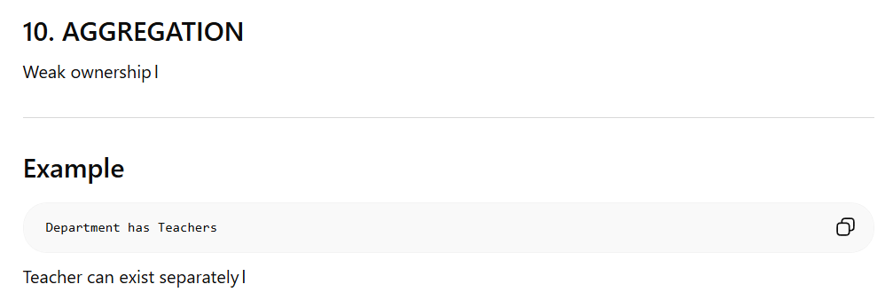
Aggregation
“Has-A Relationship (Weak Ownership)”
Aggregation means:
object contains another object
BUT contained object can exist independently।
Real-world Example
Department has Teachers
Department destroy হলেও:
Teacher থাকতে পারে।

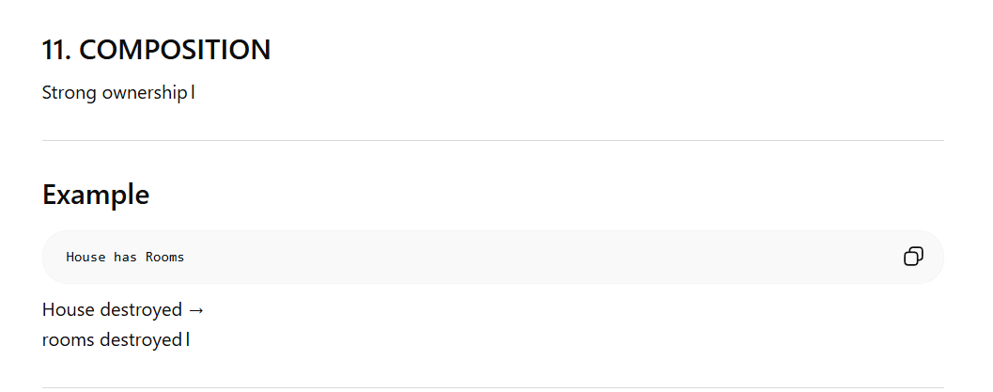
Composition
“Strong Ownership”
Composition means:
child object fully owned by parent
Parent destroy →
child also destroy।
Real-world Example
House has Rooms
House না থাকলে rooms-এর meaning নেই।

int main()
{
Animal* an = new Dog();
delete an; // warning
}
Problem:
- an is an Animal*
- actual object is Dog
- base destructor is not virtual
So only Animal destructor may run, not Dog destructor → can cause resource leaks or undefined behavior.

Fix
Make base class destructor virtual:
class Animal
{
public:
virtual ~Animal()
{
std::cout << "Animal destroyed\n";
}
};
Now both destructors run properly.

Abstract class Vs Interface
1. ABSTRACT CLASS
Abstract class:
কিছু implementation থাকতে পারে
AND
কিছু incomplete function থাকতে পারে

Example
class Shape
{
public:
virtual void draw() = 0;
void info()
{
std::cout << "This is Shape";
}
};

2. INTERFACE
Interface means:
only contract
NO implementation

Example
class IPrinter
{
public:
virtual void print() = 0;
virtual ~IPrinter() {}
};

Here
Everything:
pure virtual
No actual implementation।

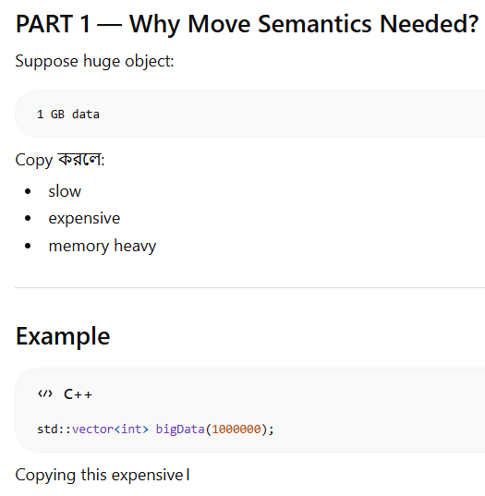

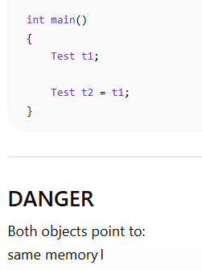
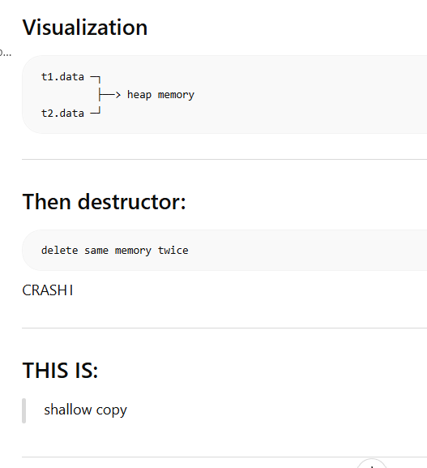s

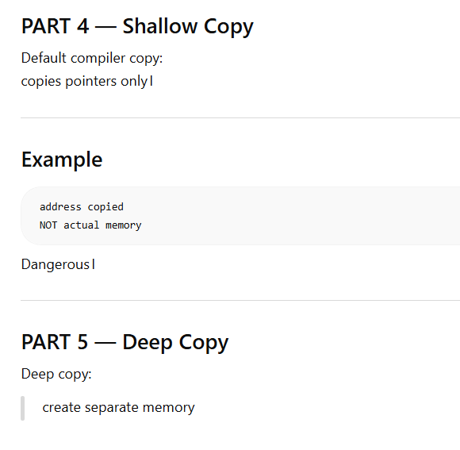
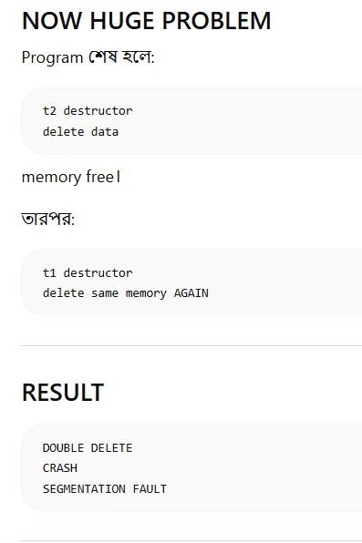

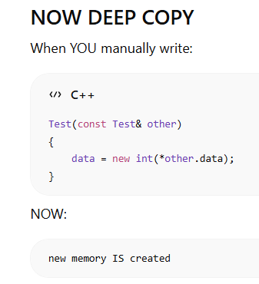
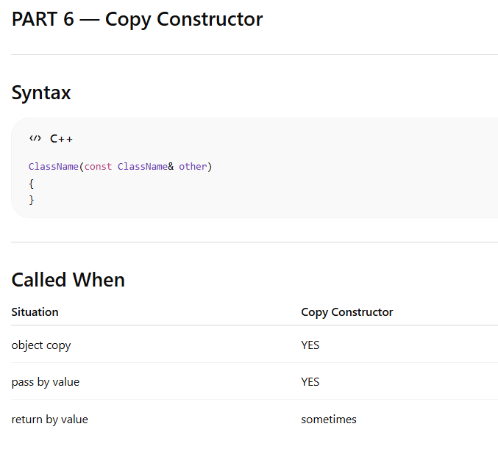
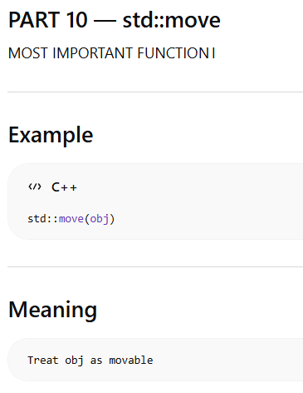

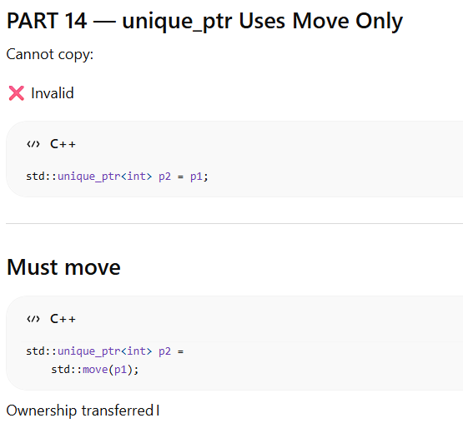


Resource management & smart pointers

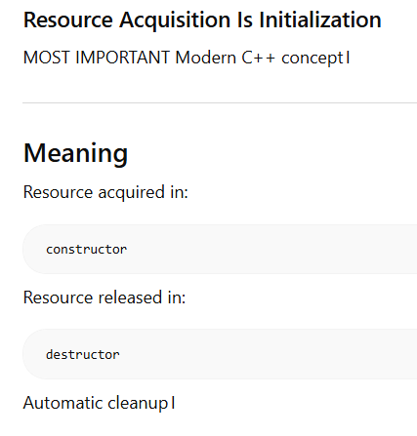
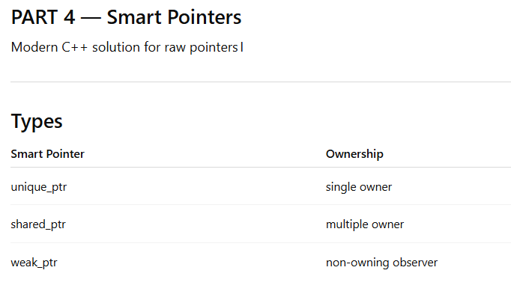
Unique_ptr -> only one owner allowed -> no delete needed (Automatic cleanup)
unique_ptr
↓
heap memory
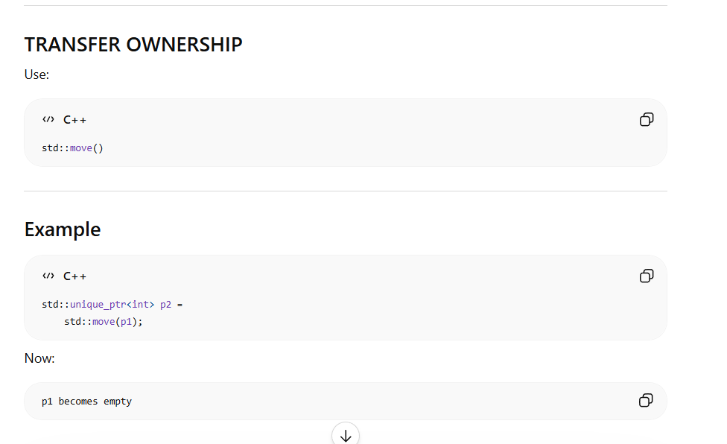

Shared_ptr ->
Shared Ownership
Multiple objects can own same memory।
p1 ─┐
├──> heap memory
p2 ─┘

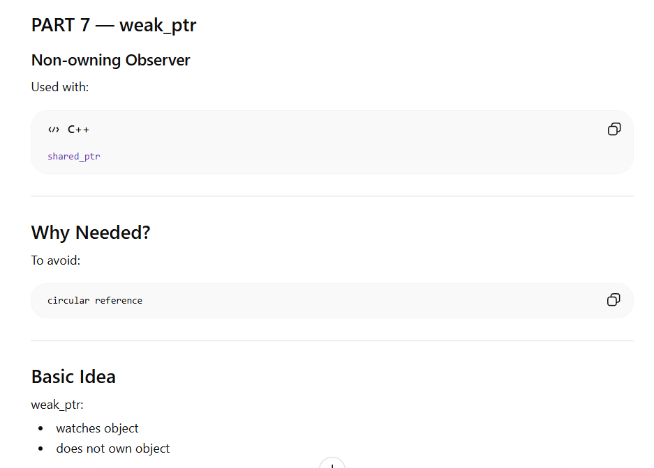
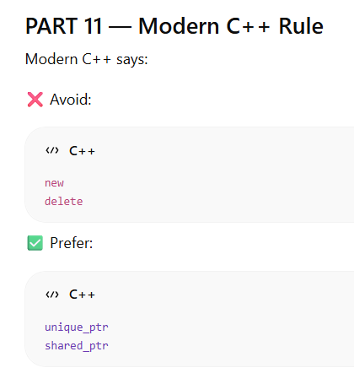
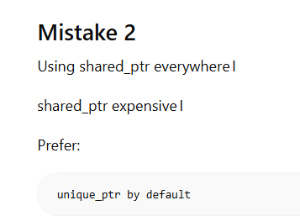
STL library –
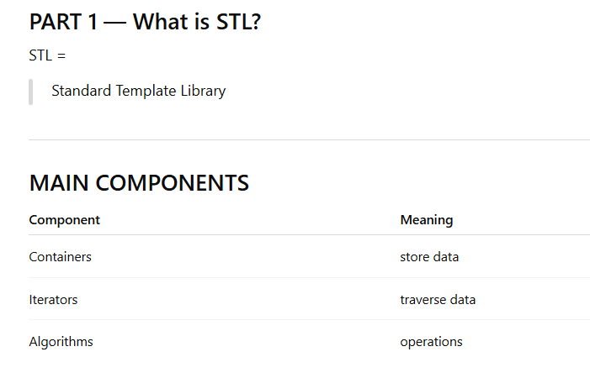
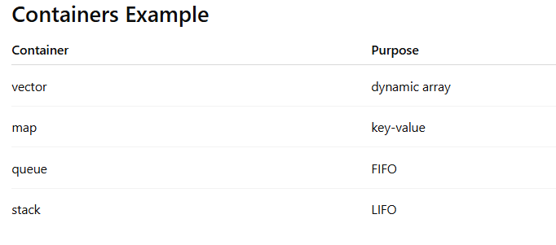

Vector ->
Most used STL container
vector সুবিধা
- dynamic size
- automatic resizing
- safer
- convenient
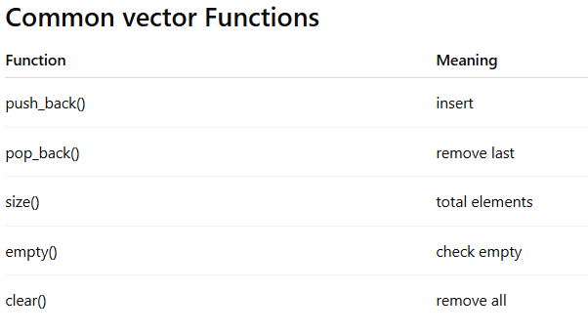
Loop Through vector
for(int i = 0; i < nums.size(); i++)
{
std::cout << nums[i] << std::endl;
}

Modern Loop
for(auto n : nums)
{
std::cout << n << std::endl;
}

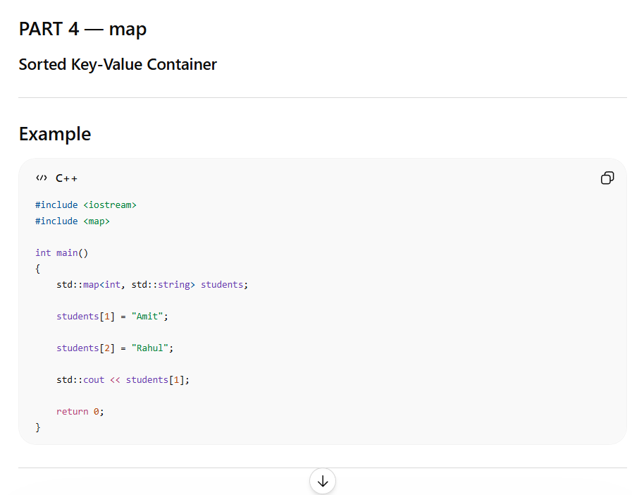
Internal Structure
Usually:
Red-Black Tree
Sorted automatically

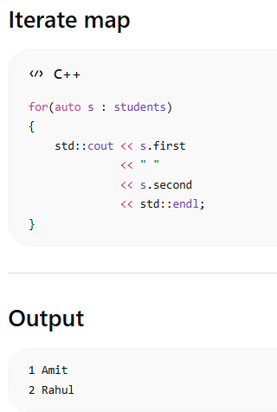

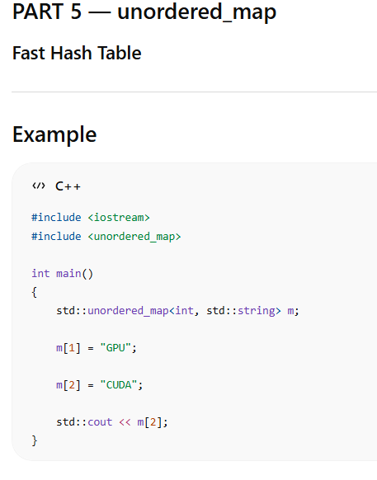

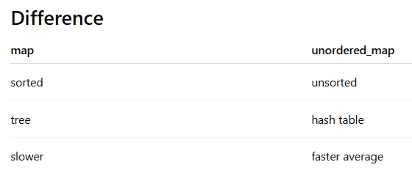
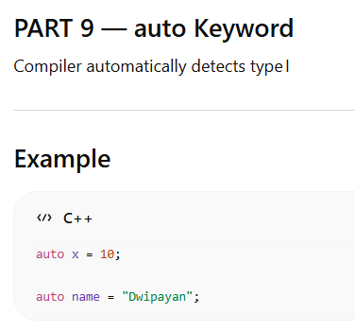
Algorithm –
#include <algorithm>
#include <iostream>
#include <vector>
#include <algorithm>

int main()
{
std::vector<int> nums = {5,2,8,1};

std::sort(nums.begin(),
nums.end());

for(auto n : nums)
{
std::cout << n << " ";
}
}
Reverse - std::reverse(nums.begin(),
nums.end());
find - auto it = find(nums.begin(),
nums.end(),
8);

Tempate –
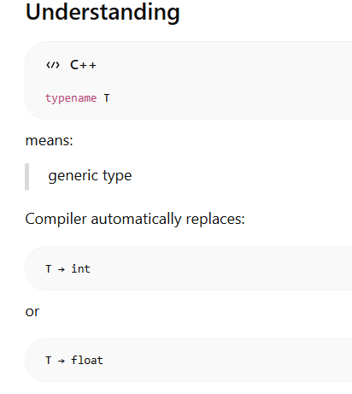
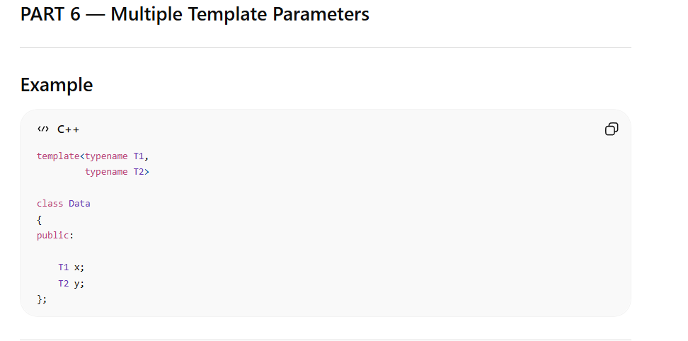

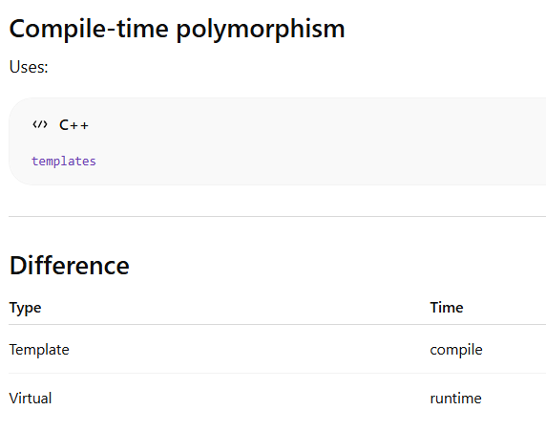

Lamdba
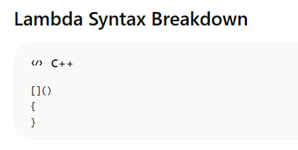
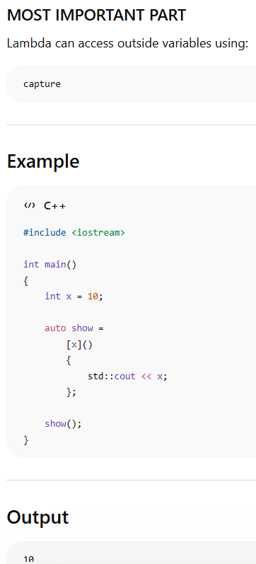
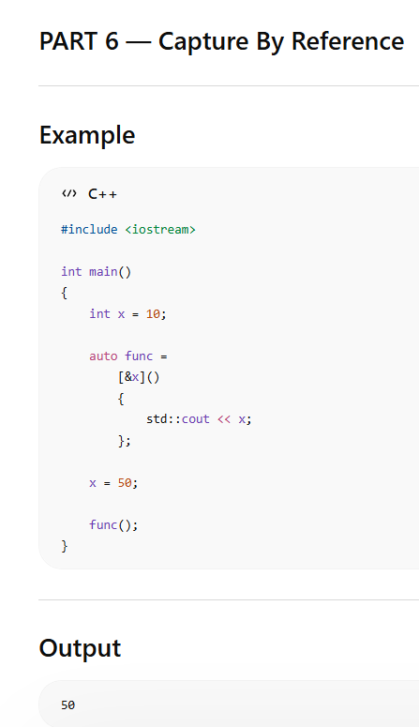
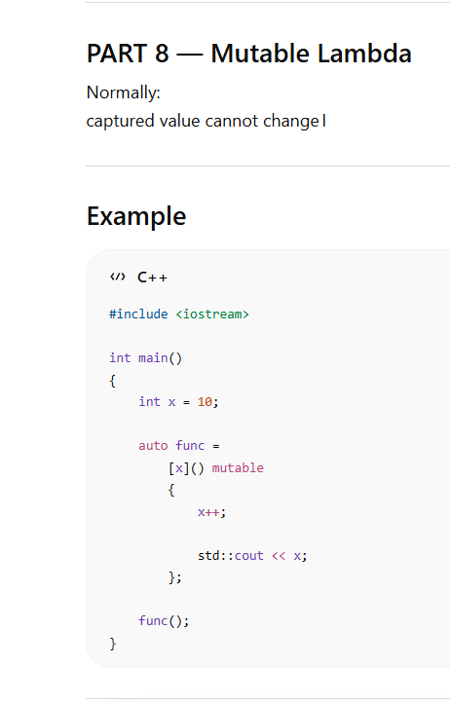
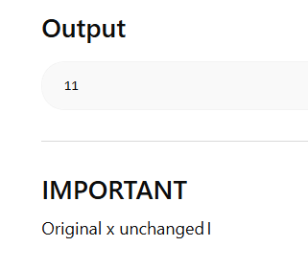

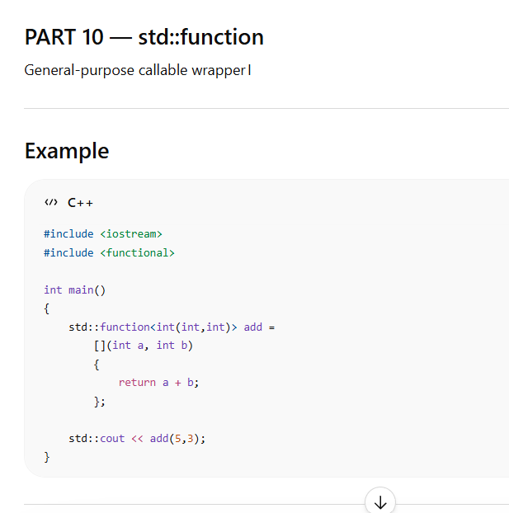
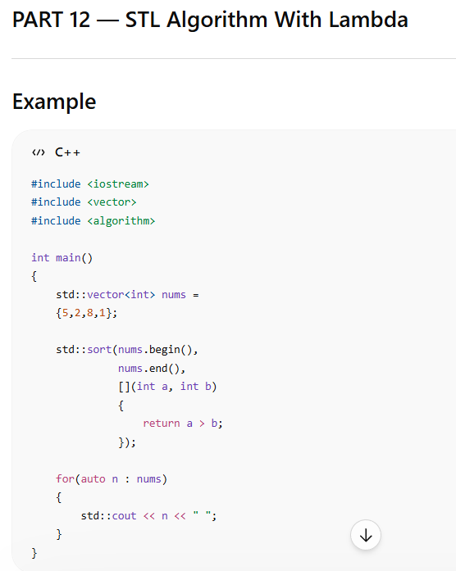

Threads –
PART 1 — What is Process?
Process =
running program

Example
Suppose তুমি run করলে:
./app
Linux creates:
process
Process Contains
- memory
- threads
- stack
- heap
- file handles
PART 2 — What is Thread?
Thread =
execution path inside process

Visualization
Process
├── Thread 1
├── Thread 2
└── Thread 3

IMPORTANT
Threads:
- share same memory
- run concurrently

PART 3 — Why Multithreading Needed?
Without threads:
one task at a time
With threads:
multiple tasks simultaneously

Compile
g++ main.cpp -Wall -Wextra -std=c++17 -pthread -o app

IMPORTANT
-pthread
required for threading support
std::thread t(task);
creates:
new OS thread
std::thread t(task);
creates:
new OS thread
Main waits
until worker finishes
PART 7 — detach()

Example
t.detach();

Meaning
Thread runs independently।
Main thread:
does NOT wait

DANGER
Detached thread accessing destroyed memory:
CRASH
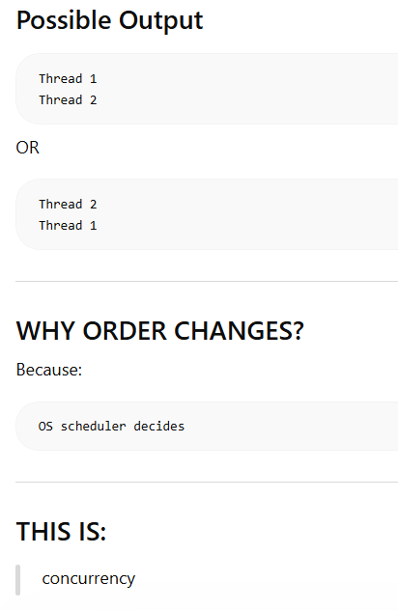

PART 10 — Mutex Basics
Mutex =
mutual exclusion
Only one thread allowed।

Create
↓
Run
↓
Join/Detach
↓
Destroy
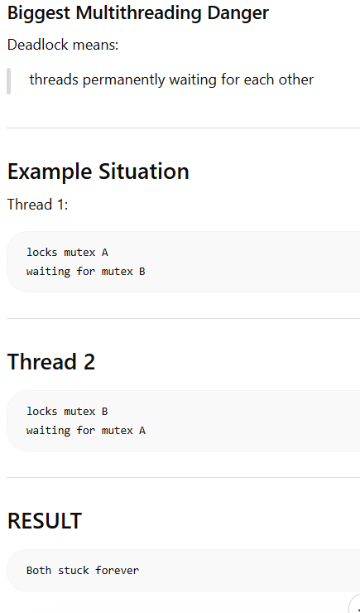
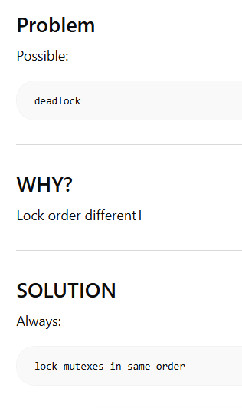
Better - std::scoped_lock lock(m1,m2);

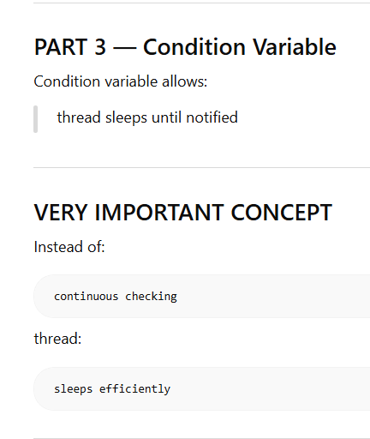

std::condition_variable cv;
এটা condition variable।
এক thread অন্য thread-কে signal দিতে ব্যবহার করে।
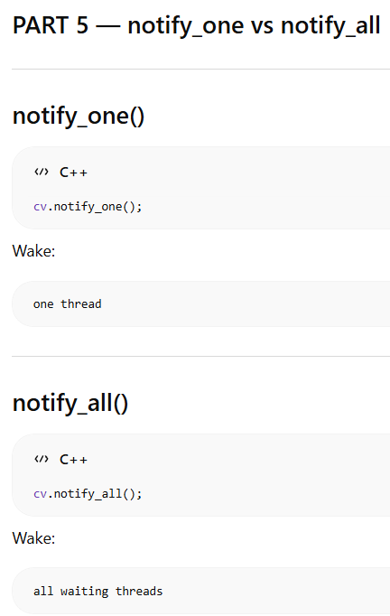

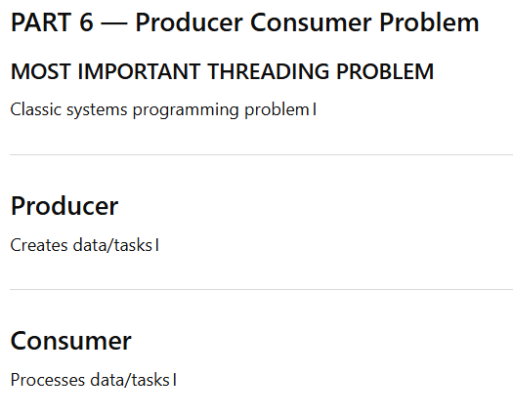

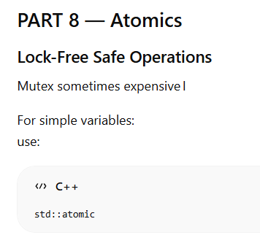

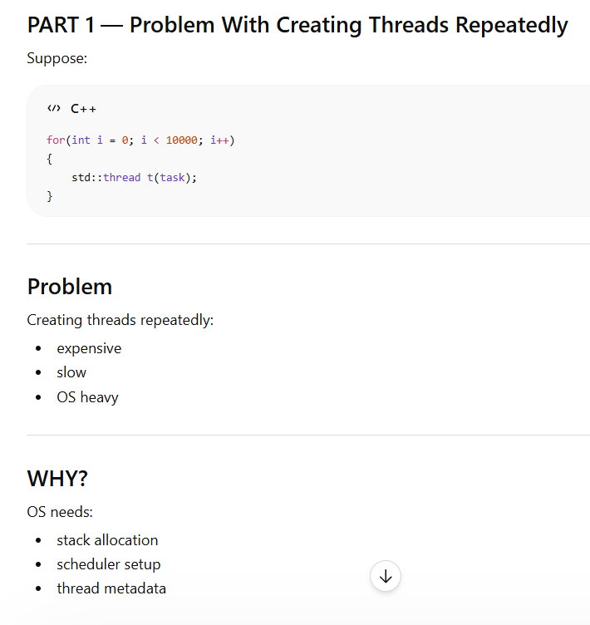
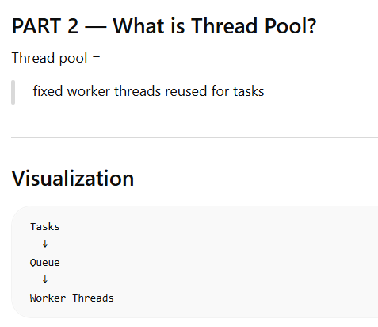

Instead of create new thread every time , reuse worker threads
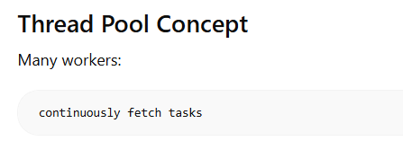

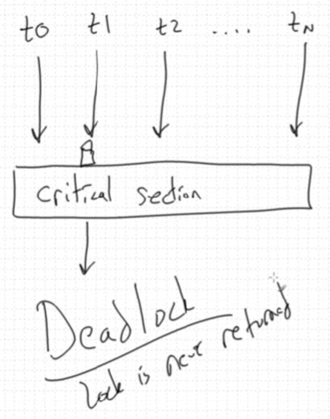

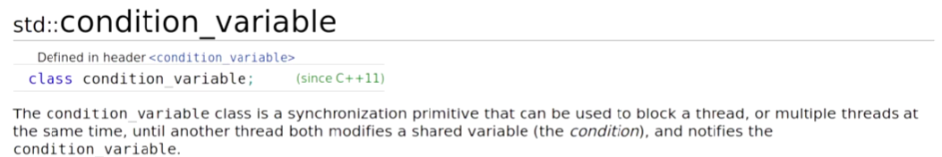
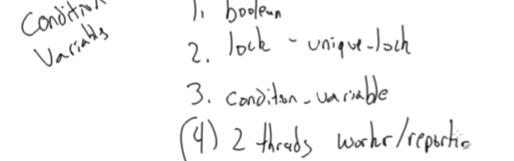

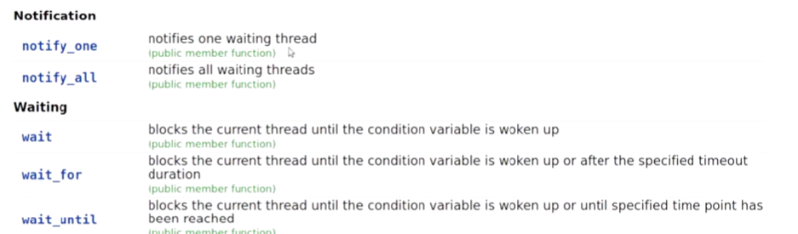

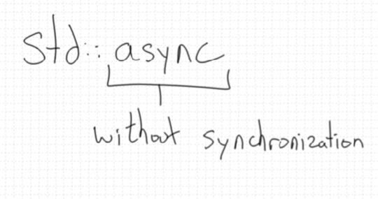
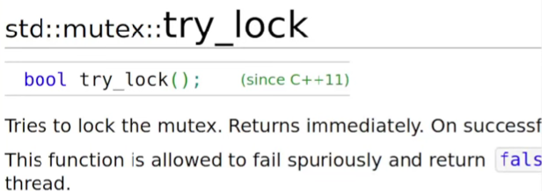
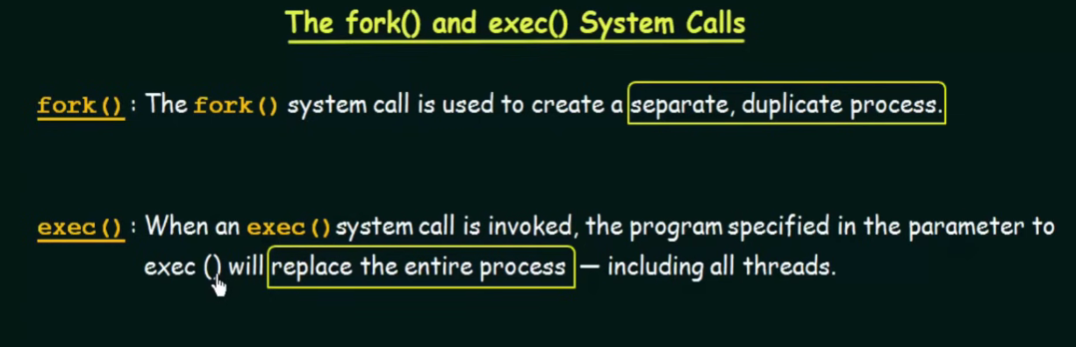

Parent Process
↓
fork()
↓
Child Process

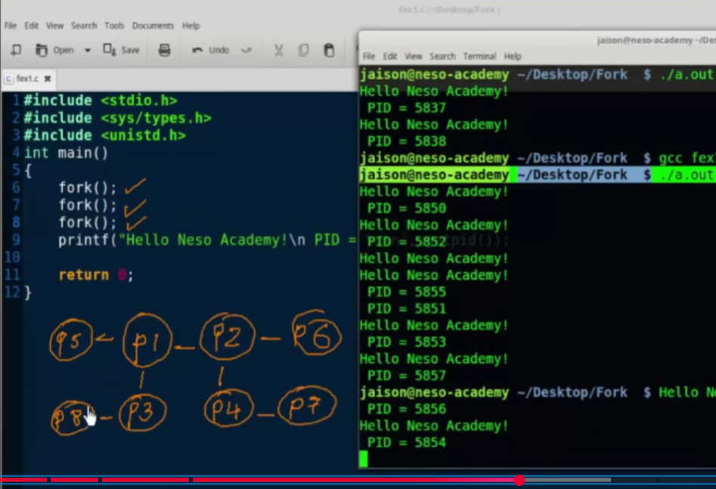
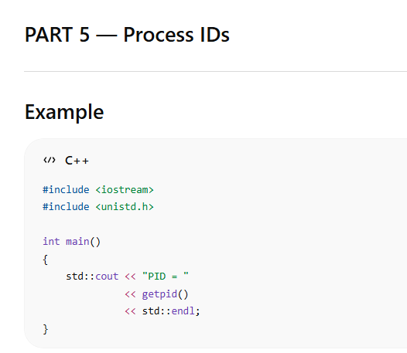
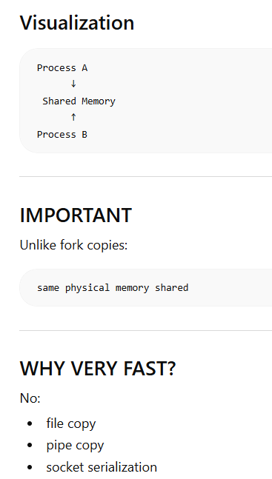
Shared memory
